Vazbu THERE IS použijeme, pokud chceme říct, že NĚKDE NĚCO je (není):

Pozor! Angličtina má odlišný slovosled:
V bytě je pes.
THERE IS
(1)

There is

There are
There isn’t
There aren’t

SOMETHING
(2)
a dog

some flowers
a dog
any trees
SOMEWHERE
(3)
in the flat.

in the bag.
in the house.
in the garden.

(1) WHAT is THERE? Look at the pictures and complete the sentences.
Be careful with „a/some/any“.

There is . . . . . . . . . . . . . . . . . . . . in the . . . . . . . . . . . . . . . . . . . . .
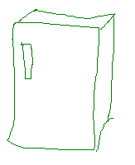

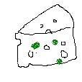

There are . . . . . . . . . . . . . . . . . . . . on the . . . . . . . . . . . . . . . . . . . . .

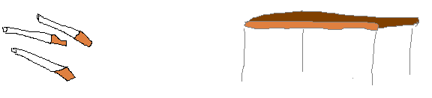

There is a beautiful . . . . . . . . . . . . . . . . . in the . . . . . . . . . . . . . . . . . . . .

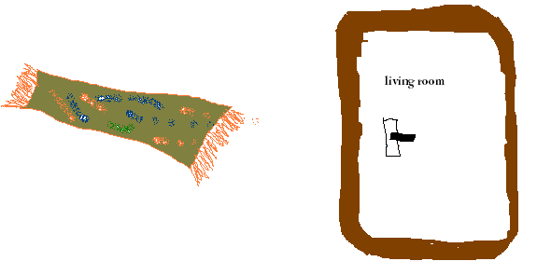

There isn‘t . . . . . . . . . . . . . . . . . in the . . . . . . . . . . . . . . . . . . . .
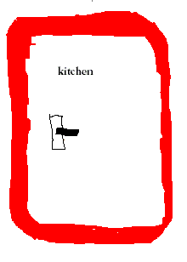
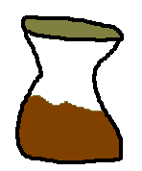

There isn’t . . . . . . . . . . . . . . . . . in the . . . . . . . . . . . . . . . . . . . .
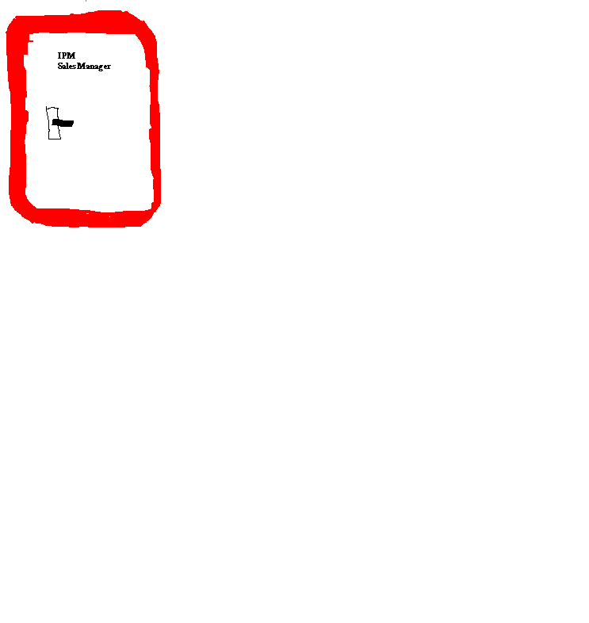

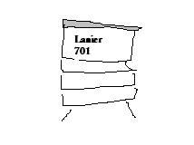

There are . . . . . . . . . . . . . . . . . in the . . . . . . . . . . . . . . . . . . . .
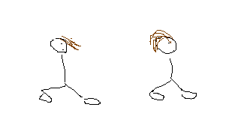

(2) Create questions.

Is there . . . . . . . . . . . . . . . . . . . . in the . . . . . . . . . . . . . . . . . . . . ?

Yes, there is.

Are there . . . . . . . . . . . . . . . . . . . . on the . . . . . . . . . . . . . . . . . . . . ?

Yes, there are.

. . . . . . . . . . . . . . . . . . . . . . . . . in the . . . . . . . . . . . . . . . . . . . . . ?

Yes, there is.

. . . . . . . . . . . . . . . . . . . . . . . . . in the . . . . . . . . . . . . . . . . . . . . . . . . ?

No, there isn’t.

. . . . . . . . . . . . . . . . . . . . . . . in the . . . . . . . . . . . . . . . . . . . . . . ?

No, there isn’t.

. . . . . . . . . . . . . . . . . . . . . . . in the . . . . . . . . . . . . . . . . . . . . . . . . ?

Yes, there are.

Answers:
(1)
There is some cheese in the fridge.
There are some cigarettes on the table.
There is a beautiful carpet in the living room.
There isn’t any coffee in the kitchen.
There isn’t a copier in the office.
There are some people (2 people) in the office.
(2)
Is there any cheese in the fridge?
Are there any cigarettes on the table?
Is there a carpet in the living room?
Is there any coffee in the kitchen?
Is there a copier in the office?
Are there any people in the office?
Neurčitý člen „a“ použijeme v jednotném čísle („a carpet“)
u počitatelných podstatných jmen (1 carpet, 2 carpets).
V množném čísle a u nepočitatelných podstatných jmen (some cigarettes, some cheese) použijeme „some/any“.
„Some“ použijeme v kladné větě, „any“ v otázce a záporu.

